# Static Testing and Dynamic testing

## Static Testing

**# Source**: **Chatgpt (GPT-5-Standard) at [8/12/2025]**

* **Meaning:** Testing **without executing the code**.
* **Purpose:** Find defects early by checking documents, design, and source code for errors.
* **Where in the process:** Happens **early in the Software Development Life Cycle (SDLC)** — before or during coding.
* **Examples:**
  + Reviewing requirement documents for clarity and completeness.
  + Code inspections or walkthroughs.
  + Using static analysis tools to catch syntax or style issues.
* **Who does it:** Developers, QA, or business analysts in review meetings.

## Dynamic Testing

**# Source**: **Chatgpt (GPT-5-Standard) at [8/12/2025]**

* **Meaning:** Testing **by executing the code** to check if it behaves as expected.
* **Purpose:** Verify the software’s **functionality, performance, and behavior** in real or simulated environments.
* **Where in the process:** Happens **after the code is written and compiled** — during test execution phases.
* **Examples:**
  + Unit testing
  + Integration testing
  + System testing
  + User acceptance testing (UAT)
* **Who does it:** Testers, QA engineers, sometimes end users.

## Quick Comparison Table

**# Source**: **Chatgpt (GPT-5-Standard) at [8/12/2025]**

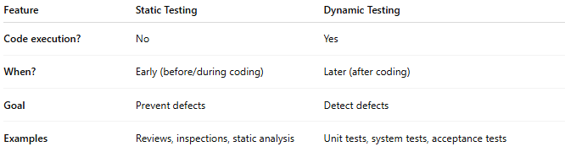

| **Feature** | **Static Testing** | **Dynamic Testing** |
| --- | --- | --- |
| **Code execution?** | No | Yes |
| **When?** | Early (before/during coding) | Later (after coding) |
| **Goal** | Prevent defects | Detect defects |
| **Examples** | Reviews, inspections, static analysis | Unit tests, system tests, acceptance tests |